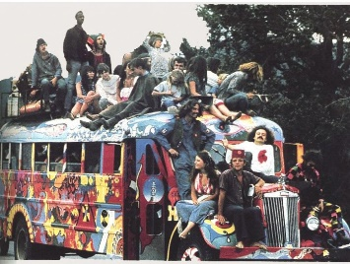
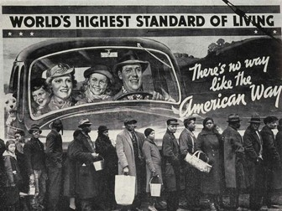
Theme 4:
The Changing
Quality of Life
Quick Start: Give the answer for each statement on leisure and travel in the USA between 1917-80.
- The most popular form of entertainment in the 1920s.
- The amount of money spent on the leisure industry in 1929.
- These towns saw significant growth & expansion due to the expansion of the film and gambling industries.
- Millions of Americans engaged in sport through this new media in the 1920s.
- Sportsmen increasingly gained celebrity status, like this baseball star of the 1920, whose poor background reaffirmed belief in the American Dream.
- In the 1920s, the rise in the number of American’s owning this gave greater freedom, regional connectivity and led to the growth of suburbs.
- The 1920s saw the birth of this particular industry, but was not commercialised until 1928.
- The leisure industry, particularly movies and sport, helped to boost this during the depression & WWII, although the quality, of the latter in particular, was hindered during war.
- This sport was particularly popular amongst black Americans.
- In 1932, American Airlines offered to fly this NYC Governor to Chicago to boost public confidence in flying, amid fears over safety.
- Aviation in the period 1933-45, was really only accessible by this class of people.
- In the 1950s, the economy was boosted by the growth of this industry, which led to the expansion of air travel, credit cards, travel agencies, and motel and restaurant chains.
- Critics [of the industry named in answer 12] were worried about its impact on the local landscape and identities of this group of people, in particular; however, it did provide seasonal income.
- Some decrease in attendance at live sporting events due to this new technology in the 1950s.
- This president built an interstate highway, helping foster a car-owning culture.
- During the 1950s, a car-owning culture led to a rise in this particular phenomenon from inner-city areas, resulting in the growth of ghettos.
- In 1948, the first of this particular type of flight was launched by capital Airlines.
- This particular industry helped many Americans feel patriotic and became a symbol of a rejection of the counter-culture.
- Despite air travel becoming cheaper, faster and safer, cars still carried this proportion of intercity passenger traffic in 1960.
- In 1978, this initially makes airline travel more affordable, but leads to a reduction in routes.
Mark each on a scale of 1-5
1= very confident / sufficient / effective – 5 = Never heard of it / action needed!
Theme and topic: |  | How confident am I? | I have  sufficient  notes on this topic. | I have given evidence of my wider reading for this topic. | I have sufficient revision materials for this topic. | I have started to revisit and consolidate this topic during independent study. | I have completed practice essays for  this topic. | Actions needed and taken  (list details)
Theme 4: The changing quality of life, 1917–80

The economic environment | boom, bust and recovery, 1917–  41
the impact of the Second World War, post-war affluence
and growth, 1941–69
 | the challenges of the 1970s.
hanging living standards | fluctuations in the standard of  living, 1917–41
the impact of the Second World War and the
growth of a consumer society, 1941–60
the impact of antipoverty
policies and economic divisions, 1961–80.

Leisure and travel | the reasons for, and the impact of,  increased leisure time, 1917–80
the growth of spectator
sports
the development, and influence, of a car-owning
culture and improved air travel.
Theme 4: The changing quality of life, 1917-80
In studying Theme 4 have considered the extent to which the quality of life in the USA in the years 1917–80 was affected by the economic environment and increasing aspiration. Detailed knowledge of economic policies and measures are not required but you should be aware of the patterns of economic change and their effects on living standards. You should also be aware of the benefits and gains across the period and that different social groups had differing experiences. You should have an understanding of the extent to which developments in leisure and travel affected the quality of life, and identify relevant examples.

Overview of the Changing Quality of Life: 1017-80
Match up the time period in each theme to the correct description of key change.
AFFLUENCE | 1917-33 |  | Period of recovery (New Deal) and birth of social security. war significant in mobilising industry for economic recovery.
 | 1933-45 |  | Wartime industry boom continues: economy stimulated by pent up demand, population growth, cheap oil & advances in science & tech.
 | 1945-61 |  | Energy crisis due to oil embargo, industrial decline due to fuel shortages & foreign competition, and high inflation.
 | 1960s |  | Period of economic boom & growth of the car industry. Credit culture & rise of consumerism. Growth followed by economic depression.
 | 1968-80 |  | Unprecedented period of economic growth leads to optimism. War leads to tax hikes, inflation & huge deficit in the federal budget & trade.

STANDARD OF LIVING | 1917-33 |  | Anti-poverty a key issue: Medicare, Medicaid & the OEO established. Expansion in education funding, but problems persist in inner cities.
 | 1933-45 |  | More home ownership & household amenities, but mainly limited to cities – rural poverty high. Bust = unemployment & homelessness.
 | 1945-61 |  | Increased poverty & homelessness, wage freezes, people told to reduce heating & carpool. Less disposable income = lost faith in Am. Dream.
 | 1960s |  | Varied poverty, but malnourishment & disease common. New Deal gave employment. Wartime rationing, but more money for leisure & saving.
 | 1968-80 |  | High income, low unemployment. More home ownership & amenities. Consumerism & labour-saving devices seen as American Dream, but wealth disparity (especially for Native Americans).

LEISURE & TRAVEL | 1917-33 |  | Boom in tourism & related industries. Sports commercialised, but some fewer attendance due to TV. Car owning culture & growth of suburbs = white flight, but development of rural areas. Air travel more affordable.
 | 1933-45 |  | Fitness & health boom (both mental & physical); recreational drug use. Sports a way to show Americanism. Cars dominate, but air now cheaper.
 | 1945-61 |  | Movies and sports raise morale, but sports suffered from low attendance & enlistment. Increase in air travel for rich, but questions over safety.
 | 1960s |  | Further tourist boom breaks down regional barriers; further corporate sponsorship in sport; cars = further growth of roadside services but damage to inner cities & less transport. Flying common & deregulated.
 | 1968-80 |  | Increased leisure time & cinema boom. Growth of spectator sports & beginning of growth in car ownership. Birth of aviation industry.

Challenge: What patterns can you see that affect affluence, standard of living, and leisure & travel?

A House Through Time: Changes in the Standard of Living.

1917-28

1928-40 (Great Depression)

1941-45 (WWII)

1945-61

1960s

1968-80

What is the correlation between increases in standard of living and affluence?

LOW STANDARD OF LIVING HIGH
LOW ECONOMIC PROSPERITY HIGH
What is the correlation between leisure and travel and affluence?

LOW LEISURE AND TRAVEL HIGH
LOW ECONOMIC PROSPERITY HIGH

Practice Essay Question
How far do you agree that, in the years 1945-80, the main reason for changes in the leisure activities of ordinary Americans was their growing affluence? [20]
- Decide what factors you might use in this question.
- Come up with at least two examples that you could use for each factor (detail not needed, yet).
- Make links between the factors. Use arrows to help you do this.
- When you are done, check the ‘indicative content’ on the next page, to check your work.

Conclusion:

2018 Exam Question:
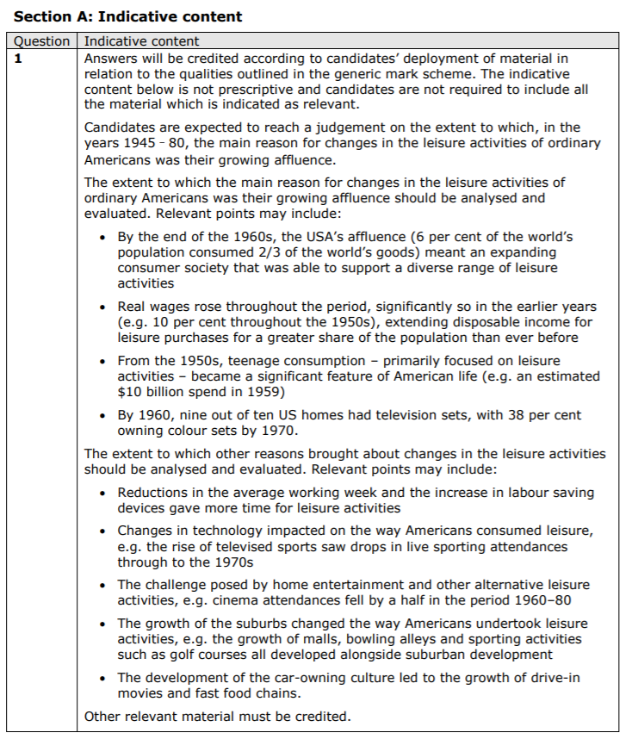
How far do you agree that, in the years 1945-80, the main reason for changes in the leisure activities of ordinary Americans was their growing affluence? [20]
Edexcel A-Level History
Papers 1 and 3 – establishing and using criteria

On the mark schemes for all the new Edexcel A-Level papers, there is a requirement to establish and use criteria in your judgements. This just means showing the examiner how you can measure the extent of something.

But this is not hard to do - it simply means being clear about the reasons for the judgements you make!

Here are some thoughts for how you can do this on Papers 1 and 3…….

Change/Continuity, Significance, and Similarity/Difference criteria (to judge the extent)
* Amount of people affected – consider social class, geographical spread, age and gender
* Length of change or impact – short or long term?
* Deep difference or lots of progress compared to previous situation – e.g. in attitudes or policies
* Speed or pace – happened quickly or slowly over time?
* Effectiveness – accepted or resisted?
* Level of threat to the status quo

Consequence criteria (to judge the most significant consequence)
* Speed or pace – effects happened quickly or slowly over time?
* Effectiveness – accepted or resisted? Achieved aims?
* Coherence/consistency – stayed the same or adapted?
* Lead to or connected to other effects

Causation criteria (to judge the most significant cause)
* Connections to other causes
* Presence in a range of factors
* Level of threat to the status quo
* Trigger – present for a short time, but without it the event or change may not have happened when it did
* Underlying – present for a long time and created the conditions for an event or change to happen

The criteria you use will depend on the conceptual focus of the questions and the topic focus

Don’t overdo it – keep to around 3 criteria for any one question

For some questions, you could structure your answer around the criteria

In reaching a judgement, you should also evaluate the relative significance of criteria – for example in judging the extent of change you might conclude that something which affects all social classes is more significant than something that lasts a long time (or vice versa!)

Q1 2018 Exam: What did the examiners say?
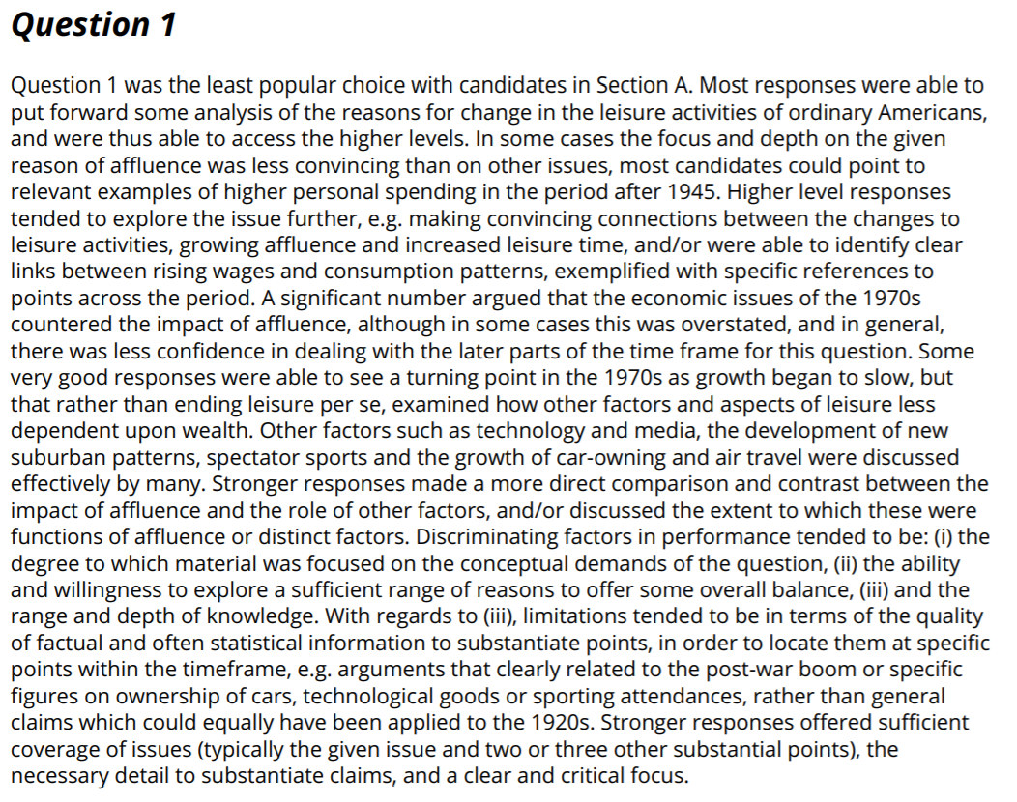

What did a successful response to this question look like?
Create a brief list of dos and don’ts for this question.
Do | Don’t

Model Answer
How far do you agree that, in the years 1945-80, the main reason for changes in the leisure activities of ordinary Americans was their growing affluence? [20]
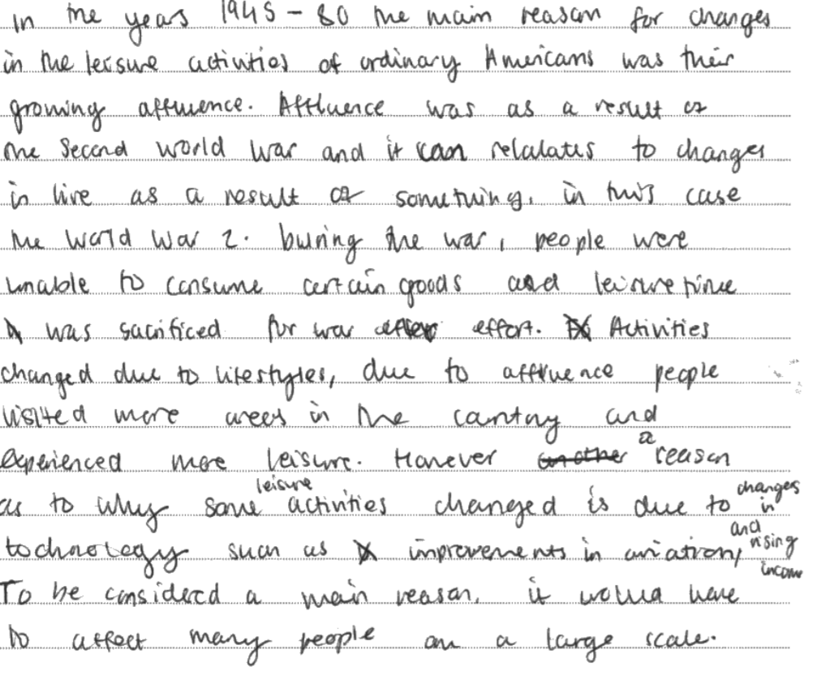
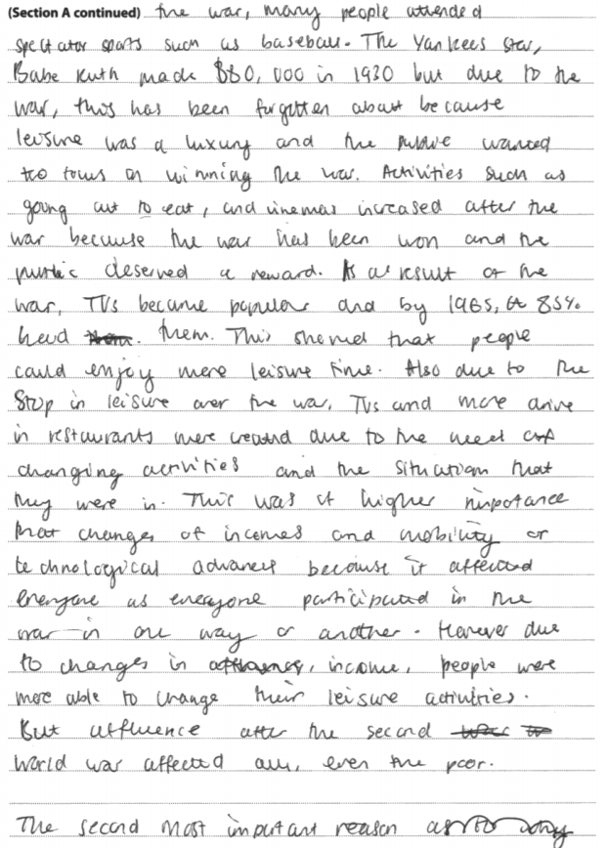
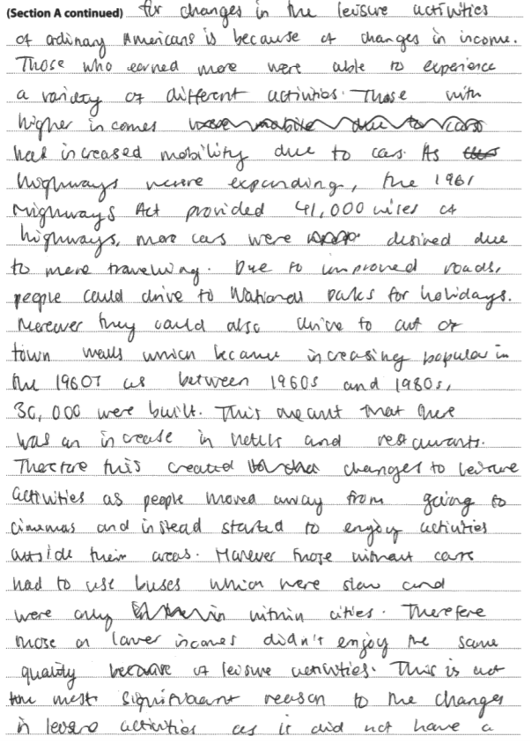

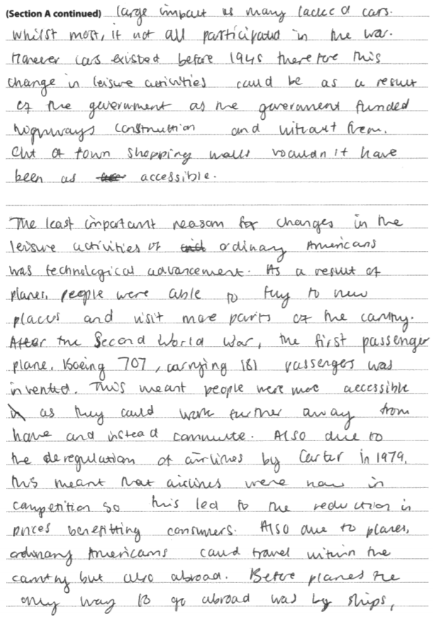 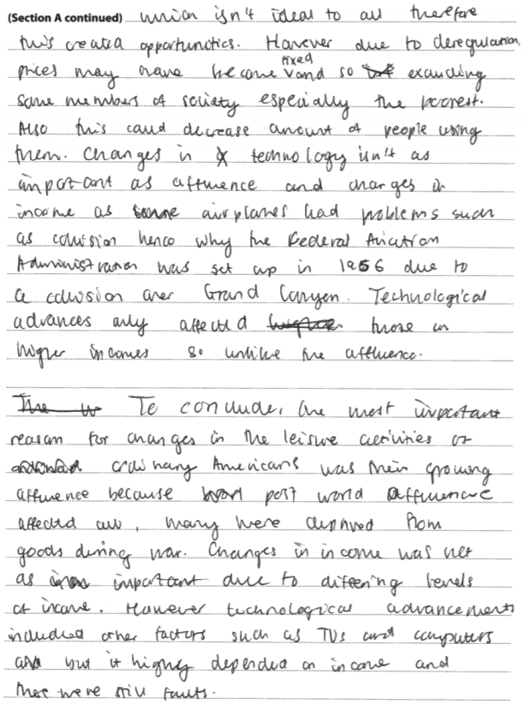Examiner comment:
This response demonstrates some of the qualities of a level 5 essay. The answer is clearly organised and focused, with a sound grasp of what the question is asking. The candidate is able to offer a range and depth of specific knowledge, and apply this to examine the role played by affluence, largely sustaining and analysis which considers this alongside a range of other factors. The argument is logical and reasoned, and the candidate produces a reasoned judgement. Development is coherent and shows a grasp of the demands of this particular question.
Practice Essays

Section 1.4 The Changing Quality of Life

- How far had the standard of living achieved in America before the Wall Street Crash of 1929 been recovered by 1941? [2015 SAM]
- How significant was the post-Second World War population boom in the creation of a consumer society in the USA during the 1950s and 1960s? [2015 SAM]
- How accurate is it to say that living standards in the USA were transformed for the better in the years 1941-80? [2017 Exam]
- How far do you agree that the impact the Second World War had on American politics and society was very different from that of the First World War? [2017 Exam]
- How far do you agree that in the years 1945-80, the main reason for changes in the leisure activities of ordinary Americans was their growing affluence? [2018 Exam]
- How far do you agree that confidence was the most significant factor in both the affluence of the 1950s and the crisis of the 1970s? [Pearson Textbook, p.100]
- How far do you agree that the car changed the face of the USA in the years 1917-1980? [Pearson Textbook, p.113]
- Was the Second World War the main reason for post-war affluence in the 1950s? (20) [AS Section A, Pearson textbook page 95]
- How significant was the growth of credit in the USA in the 1920s in producing the Great Depression of the 1930s? (20) [AL Section B, Pearson textbook page 158]
- How far do you agree that Americans achieved unprecedented prosperity between 1917-28? [Hodder Textbook, p.45]

